Analysis of MGNREGA Data to Understand Rural Poverty Trends in India

1. Introduction
Poverty remains a major socio-economic challenge in India, particularly in rural areas where dependence on agriculture and informal employment is high. To address this issue, the Government of India launched the Mahatma Gandhi National Rural Employment Guarantee Act (MGNREGA), which guarantees at least 100 days of wage employment to rural households.
This project uses MGNREGA data analysis to understand employment patterns, women participation, wage distribution, and employment days across Indian states. The analysis helps in interpreting poverty levels and regional disparities, making MGNREGA data an important indicator for assessing the rural poverty rate in India.

2. Objectives of the Study
The main objectives of this project are:
- To analyze state-wise participation in MGNREGA
- To study women’s participation in rural employment
- To evaluate average employment provided per household
- To examine the relationship between employment, wages, and workforce size
- To understand how MGNREGA data reflects rural poverty levels in India

3. Data Description
The dataset used in this project contains state-wise MGNREGA information, including:
- Total registered workers
- Active workers
- Average employment days per household
- Average wage rate
- Women person-days
This data enables a comprehensive analysis of employment generation and income support provided under MGNREGA.

4. Methodology
The analysis was carried out using Python and Jupyter Notebook, following these steps:
- Data loading and cleaning
- Handling missing values and column standardization
- Exploratory Data Analysis (EDA)
- Visualization using bar charts, histograms, scatter plots, box plots, and heatmaps
- Interpretation of results in the context of rural poverty

5. Role of Data Visualization
Data visualization plays a crucial role in this analysis by:
- Simplifying complex datasets
- Highlighting state-wise disparities
- Identifying trends in employment and wages
- Supporting evidence-based policy evaluation
Visual tools help policymakers and researchers quickly identify regions with high poverty dependency and low employment outcomes.

6. Analysis and Interpretation (Question–Answer Based)

Q1. How does women participation vary across states?
Women’s participation under MGNREGA varies significantly across Indian states. States such as Rajasthan, Kerala, Tamil Nadu, Andhra Pradesh, and Chhattisgarh show higher women person-days, indicating strong female involvement in rural employment programs. In contrast, states like Uttar Pradesh and Bihar, despite having large workforces, show relatively lower women participation.
Poverty Interpretation: Higher women participation improves household income stability, food security, and social empowerment, which are critical factors in reducing rural poverty.
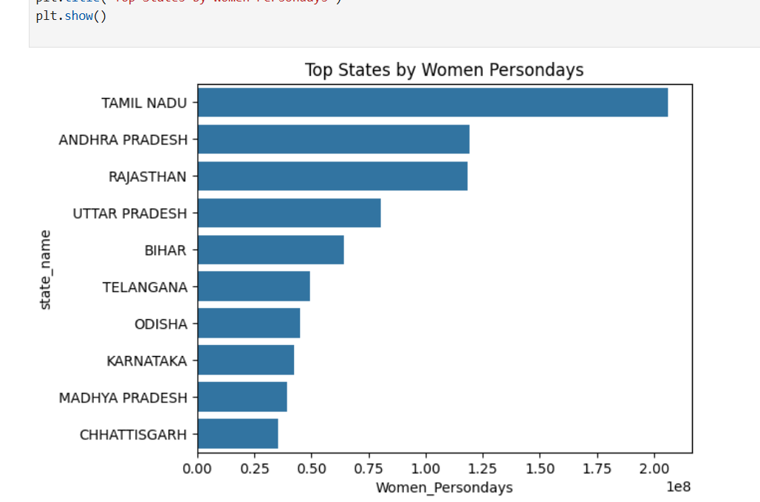

Q2. What is the average employment provided per household?
The analysis shows that the average employment provided per household is generally below the guaranteed 100 days, mostly ranging between 40–60 days across states. Only a few states perform better in providing higher employment days.
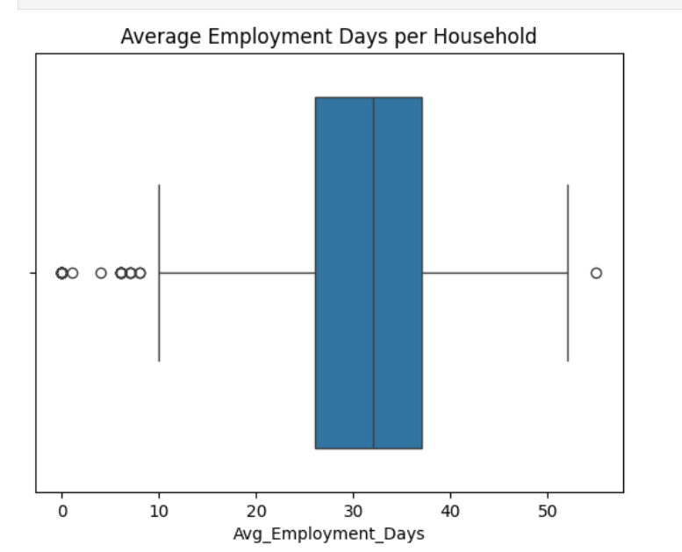
Poverty Interpretation: This indicates that while MGNREGA reduces poverty, incomplete employment limits its ability to lift households fully above the poverty line.

Q3. Which states have the highest MGNREGA worker participation?
States with the highest MGNREGA worker participation include:
- Uttar Pradesh
- Bihar
- Rajasthan
- Madhya Pradesh
- West Bengal
These states have large rural populations and limited alternative employment opportunities.
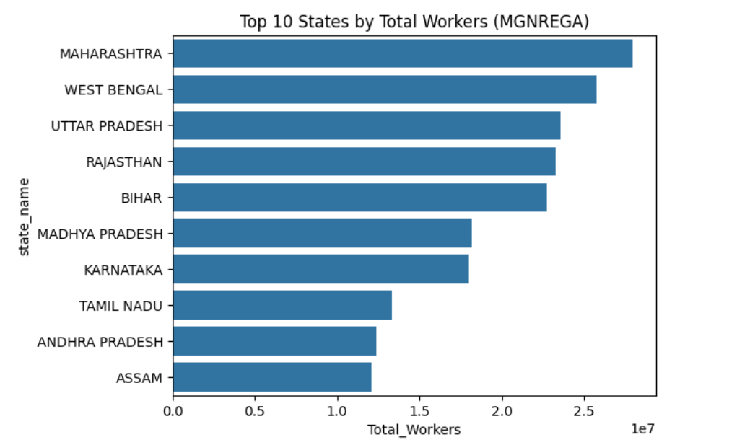
Poverty Interpretation: High participation reflects higher rural poverty and dependence on government employment schemes.

Q4. Do states with more workers provide more employment?
The analysis shows a positive but imperfect relationship between the number of workers and total employment generated. While more workers generally lead to higher total employment days, employment per household does not increase proportionally.
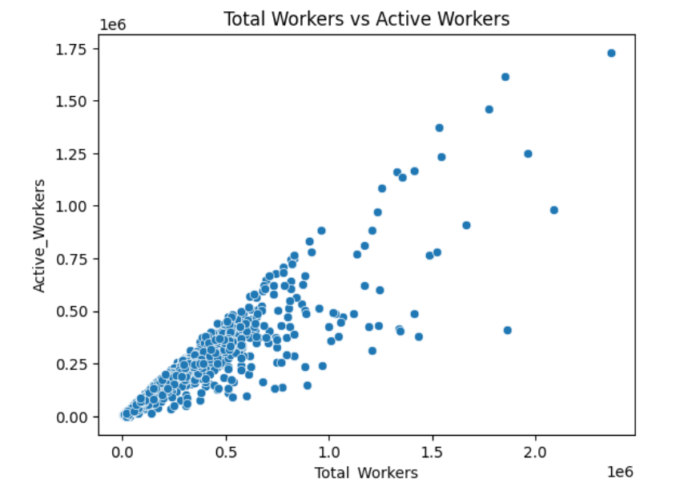
Poverty Interpretation: This highlights administrative and resource constraints that affect poverty alleviation outcomes.

Q5. Does higher women participation improve employment outcomes?
Yes, states with higher women participation tend to show better employment utilization, more stable work availability, and improved household-level employment outcomes.
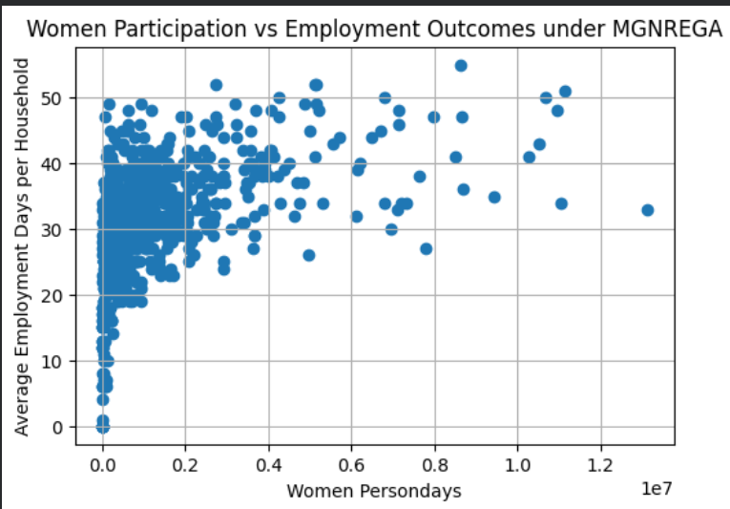
Poverty Interpretation: Women’s earnings strengthen household income distribution and help families move closer to or above the poverty line.

Q6. How does data visualization help in policy evaluation?
Data visualization enables easy identification of regional inequalities, employment gaps, and wage differences. Graphical analysis supports policymakers in targeting underperforming regions.
Poverty Interpretation: Better visualization leads to targeted poverty alleviation and efficient allocation of resources.
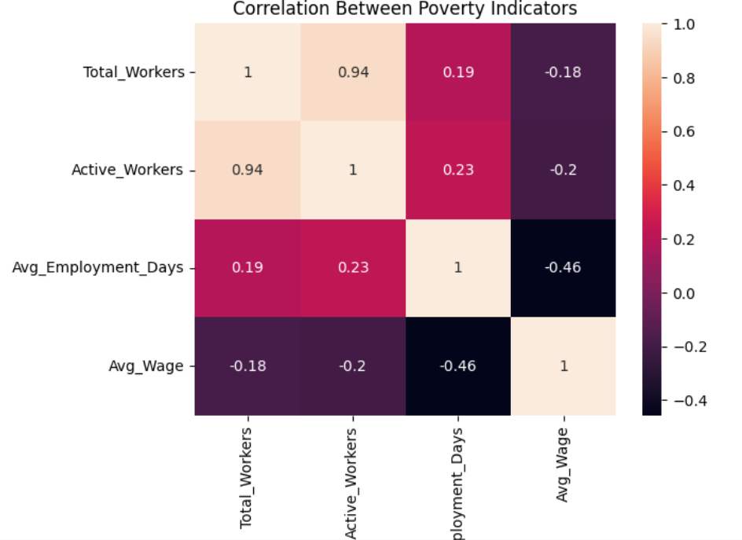

Q7. How can MGNREGA data be used to measure rural poverty?
MGNREGA data acts as a proxy indicator of rural poverty by analyzing worker participation, employment days, wages, and women’s involvement. Higher dependence on MGNREGA indicates limited income opportunities, while improved employment outcomes suggest poverty reduction.
Poverty Line Context: MGNREGA helps identify households below or near the poverty line, supporting evaluation of rural economic distress in India.

7. Key Findings
- Significant state-wise disparity in employment and wages exists
- Women participation plays a vital role in improving employment outcomes
- Average employment remains below the guaranteed level
- High MGNREGA dependency indicates higher rural poverty

8. Conclusion
This project demonstrates that MGNREGA data is a powerful tool for understanding rural poverty in India. State-wise variations in employment, wages, and women participation reveal both the impact and limitations of the scheme. While MGNREGA provides crucial income support to poor households, improving employment coverage and women inclusion can significantly strengthen poverty reduction efforts.

9. Policy Implications
- Increase employment days closer to the guaranteed 100 days
- Promote higher women participation
- Improve administrative efficiency in high-demand states
- Use data-driven visualization for targeted poverty alleviation

